
Dedicated to finding Vauter(s), Vawter(s), Vaughter(s)
Newsletter
March 2016 Volume 40 No 1
Reunion Dates:
Bentonville, Arkansas July 14-17, 2016
Central Texas July 13-16, 2017
Central Indiana July 2018

Website: www.vawterfamily.org
Officers
President Bruce Vawter, 9321 Manoroak Dr, St. Louis, MO 63126
Phone 314-849-8727 email fcsvawter@sbcglobal.net

Vice President Darren Welch, 402 N Galeston Ave, Indianapolis, IN 46229
Phone 317-899-1992 email: Darren.welch@cnoinc.com
Treasurer Jordan M. Johnston…14357 W. Lexington Ave,
Goodyear, AZ 85395 Phone 903-624-9632 email Jordan@bearcreekindustries.com
Asst. Treasurer Phil Vaughter…1103 Newport, Austin, TX 78753
Phone…512-836-3105 email PRV37@aol.com
Secretary Rebecca Guinagh, 7805 NW 28th PL Apt M101,
Gainesville, FL 32606,
Phone 352-331-2879. Email Guinaghbeck@yahoo.com
Archivist Beth Melton, 3809 Junker, Rosenberg, TX 77471
Phone 281-232-7972 email - emeltonea@aol.com
Newsletter & Georgene Jurgensen…8408 Mohican Ave
Historian Brooksville, FL 34613
Phone…816-591-0251 email gfjurgensen@gmail.com
Website & Patricia Renton…2372 Bear Creek Rd, Pipe Creek, TX 78063
Newsletter Phone…830-510-4625 email – pvrenton@gmail.com

Now is the time to make reservations for the July reunion.

Doubletree Suites by Hilton Hotel Bentonville

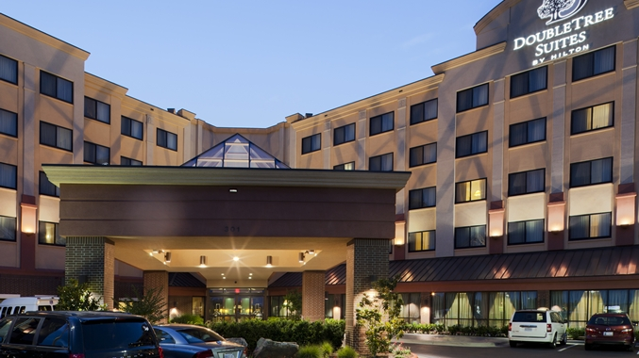
301 SE Walton Blvd
Bentonville, Arkansas, 72712, USA

GROUP CALL IN: 479-845-7770
GROUP CODE: VVV

Or ONLINE BOOKING LINK HOTEL: http://doubletree3.hilton.com/en/hotels/arkansas/doubletree-suites-by-hilton-hotel-bentonville-BNTDTDT/index.html

The Room Rate is $119 for Thursday night and $94/night for Friday and Saturday. The Double Tree has a restaurant and our breakfast is included in the Room Rate! Saturday night dinner will be $30/person

In Remembrance

Paul W. Bowman passed away on January 30, 2016. He was born in Houston, Texas on August 25, 1930 to Junie (Vawter) and Paul L. Bowman.
Paul spent most of his childhood in Pipe Creek , which is located in the Texas Hill Country. He went to elementary School at the Pipe Creek School and graduated from San Antonio Vocational and Technical High School in 1948.
Paul served in the US Marine Corp during the Korean War from 1950- 1953 in this time he achieved the rank of Sergeant. After his military service he moved to Houston and was employed at Hill Electric. He married Bonnie Brown in 1958. Together they had four children Nancy, Joseph, Rebecca and Daniel. They moved to Seguin in 1968. Paul was employed at SMI from 1968 until his retirement in 1993.
Paul was preceded in death by his son Joe, his wife Bonnie, and his daughter Nancy. He is survived by his son Daniel Bowman of Pipe Creek, his daughter and son-in-law Rebecca Bowman and Eric Cockrell of Charlotte NC, his son-in-law Craig White of California and his grandsons Ethan and Elliot White of Seguin, and his grandchildren Annabela, Joseph, and Paul Cockrell all of Charlotte NC.
Paul loved his family and Texas, especially the Hill Country and Pipe Creek. He was laid to rest in the Pipe Creek Cemetery.

San Angelo Standard Times (TX)
David Owen Cottle, 72, of San Angelo, passed away on Saturday December 26, 2015 at his residence. Visitation will be held 10:00 am to 8:00 pm Tuesday December 29, 2015 at Robert Massie Funeral Home. Funeral services will be held 2:00 pm Wednesday, December 30, 2015 at Angelo Bible Church, with Bob Hall officiating. Burial will take place at Fairmount Cemetery under the direction of Robert Massie Funeral Home. He was born on December 7, 1943 to Lorenzo and Rhea (Vaughter) Cottle in Clovis, NM.
He graduated from Eastern New Mexico University with a Masters in Business Administration in 1974. David worked as a banker for Texas Commerce Bank and retired from J. P. Morgan Chase in 2008. On May 28, 1993 he married Pat Tracy in San Angelo. He was a CPA and an active member of Angelo Bible Church and had a beautiful singing voice. He was preceded in death by his parents and a brother, Terry Cottle. David is survived by his
loving spouse of 22 years, Pat Cottle of San Angelo, son, Lorenzo Warren and wife, Lori Cottle, III of Midland, daughter, Jacquline Lori Cottle of Rumford, RI, grandchildren, Kayleigh,
Bryce and Annsley Cottle all of Midland, Olivia Cottle of Rumford, RI, a brother, Andrew and wife Rebecca Cottle of Newark, DE.

Harold E. Vawter, 87, of Topeka, passed away on Saturday, December 12, 2015. He was born June 18, 1928 in Carbondale, KS, the son of Leonard F. and Eva E. M. (Herold) Vawter.
Harold graduated from Auburn Rural High School in 1947. He was a member of the Kansas National Guard 35th Division Field Artillery Unit which was called into active duty during the Korean War. He owned and operated Vawter Sales & Service. He was a member of Philip-Billard Post No. 1650 V.F.W and Capitol Post No. 1 of the American Legion.
Harold married Betty C. Renyer on September 10, 1949 in Topeka. She survives. Other survivors include their children, Harold E. (Arlana) Vawter, II, Patricia A. Dean, Bruce E. (Kelly) Vawter, Gary L. Vawter, Penny C. Frye, Brian J. (Nancy) Vawter, 12 grandchildren and several great-grandchildren.
Harold was preceded in death by his parents, his siblings, Robert Vawter and Wilma Kneale and his son-in-law, Ronald Frye.

Page 2

James Lanier Vawter 11-21-1926 01-09-2016 He made his own arrangements, was cremated and will be buried at Linn Flat Cemetery in East Texas.
James was very interested in the Vawter genealogy and wrote several articles about his research.
Wife: Gloria Kainer Vawter, predeceased him in 2006. They were married 11-23-1947.
Daughter: Vicki Vawter Hildebrand, husband Randal
Son: Jeffrey Vawter, wife Jeanine
Grandchildren: Amy Hildebrand Manis Robinson, husband Dirk, Matthew Hildebrand, Ryan Vawter, Andrea Vawter Blythe, Husband Colby
Great grandchildren: Mikayla and John Hildebrand, Kierana and Luke Manis, Justin Pfeil, Jaxson Vawter. (Jaxson is awaiting his baby sister Lilly in June)
This obituary is from 2012 but I do not believe it was ever published in the newsletter. They were well known to the Vawter family.
Tampa, CULBREATH BAYOU — Lynda Vawter often told a story about one of her earliest impressions of Tampa. It was 1969 and she had just moved here with her husband, Robert. She had lived a refined life with her family in Ohio, then enjoyed the arts and international culture of Washington, D.C., during her college years.
She and her husband were driving down Florida Avenue. She was looking out of the window, trying to get a feel for her new hometown, when she saw a goat standing on the roof of a house, eating out of the gutter.She thought that moving to this strange place called Tampa was a huge mistake.
But Mrs. Vawter ended up spending the rest of her life in Tampa. She loved her adopted hometown and through tireless volunteer work, helped it grow from the sleepy 1960s city where goats lived on roofs to the more sophisticated city it is today. Mrs. Vawter died Feb. 20. She had been battling cancer since she was first diagnosed in the mid 1990s, but remained active until shortly before her death. She was 65.
She met her husband while they were students at George Washington University. She was an honor student, majoring in English literature and minoring in Russian. Before she graduated, the CIA tried to recruit her. By that time, however, she had her mind set on becoming a wife, mother and homemaker. Through her volunteer work with the Junior League, she was instrumental in the development of two of Tampa's best-known charitable organizations: Metropolitan Ministries and Ronald McDonald House.
"She organized our volunteer program and trained the volunteers," said Janice Davis, the CEO of Ronald McDonald House Charities. "The combination of her experience and her sense of community were invaluable in establishing the Tampa Ronald McDonald House. She had stupendous leadership qualities."
Her charismatic personality had a lot to do with her success as a community leader, Davis said."She was just very skilled at being a human being," Davis said. "When I talked to her, I always felt that she was listening very, very intently."Mrs. Vawter could wield an amazing sense of humor, Davis said, but she was at the same time very determined and low-key.
Other than her family, community and church — she was a longtime active member of St. John Episcopal Church — her other passion was sailing. She often spent weekends sailing with her husband and children, and she helped form a group called Mainsheet Mamas that taught women to sail at the Tampa Yacht Club.
After she was diagnosed with breast cancer about 15 years ago, her husband retired at age 56. Even though the prognosis was good, he wanted to spend as much time with her as possible. They sailed regularly around Florida in the cooler months, and they summered at their second home in Maine, where Mrs. Vawter volunteered at the botanical gardens.
"My father-in law retired at age 56," said Clarke Hobby, who is married to the former Laura Vawter. "He gave up a very successful law practice to be with her. Because he did that, they had a lot of quality time together, and they made the most of it."Mrs. Vawter is survived by her husband, Robert; daughter Laura Hobby; her son Robert Vawter III; her sister Janet Saas; her brother Robert Medors and two grandchildren.
Page 3

Activities planned for the July reunion in Bentonville, Arkansas

Thursday July 14th
Thursday, July 14th 6pm-8pm: BBQ Welcome dinner at the home of Chad and Denise Bugos. 4125 Caerleon Circle Bentonville AR 72712. Gated Subdivision – Chad to send gate code for June newsletter. Swimming will be the main activity; please let everyone know that we have a pool and would like for anyone who wants to swim to bring swimsuits.

Friday July 15th
Friday, July 15th 10am-12noon: Crystal Bridges Museum of American Art (http://crystalbridges.org/). 600 Museum Way Bentonville, AR 72712 Right now I have us set-up for a Free Self-Guided Tour. They will give us devices that we can use for an audio tour. There is a guided option for $10/person, but I wasn’t sure if anyone would want that because of the price.

Friday, July 15th 10am-12noon: For Families with children ages 4-9 in mind: Scott Family Amazeum Children’s Museum(http://www.amazeum.org/). 1009 Museum Way Bentonville, AR 72712 (Right in front of the Crystal Bridges Museum. Admission price is $9.50 for guests ages 2 and over. Children under 2 will be admitted free.

Friday, July 15th optional lunch: Flying Fish (http://www.flyingfishinthe.net/Bentonville.php) 109 NW 2nd St, Bentonville, AR 72712. Average price: $10-$15/person. They do have kid’s meals that are unique and very reasonably priced.

Saturday July 15th
Saturday, July 16th 7:30am-1pm optional tour: Bentonville Farmer’s Market (http://www.downtownbentonville.org/#!farmers-market/rkmm7). Located on the Bentonville Square, Downtown Bentonville. FREE – unless you buy a bunch of stuff! We will be in this area on Friday for Lunch at the Flying Fish, so everyone will know where it is located.

Saturday, July 16th 8am-10pm optional tour: The Walmart Museum (http://www.walmartmuseum.com/visit/5-10/). 105 N. Main Street Bentonville AR 72712. FREE admission.

Saturday, July 16th 10am-12noon optional tour: Pea Ridge National Military Park (http://www.nps.gov/peri/index.htm). 15930 E Hwy 62 Garfield AR 72732. Cost: $15.00 per vehicle - pass valid for 7 days.

Saturday July 16th 10am-9pm optional Family Fun: High Rise Trampoline Park “Open Jump” (http://www.highrise.us/). 4699 S. Dixieland Rd., Rogers, AR 72758. Cost: Age 6 & under: $10 – 1 hour flight ticket; Ages 7+: $13 – 1 Hr flight ticket. Walk-ins are always welcome, however we recommend purchasing flight tickets in advance in order to guarantee your flight! To purchase tickets, please click our “Tickets” tab. Remember, All who enter must sign a waiver. All participants under the age of 18 must have it signed by a parent or legal guardian. To streamline your check-in process, you may sign online by clicking our “Waiver” tab. Flights take-off every ½ hour, so please arrive 15 minutes early to prepare for lift-off. Anyone under the age of 13 must be accompanied by an Adult. Remember, you may only participate barefoot, or with our gripper socks for optimal traction.

Page 4

2016 REUNION SCHEDULE

Thursday, July 14

3:00 p.m. – 5:30 p.m………………………………………..…..……….Registration
6:00 - 8:00p.m………………………………....................................Welcome dinner
8:30 p.m………………………………………………Executive Committee Meeting

Friday, July 15
Complimentary Breakfast
8:30 – 9:00………………………………………………..……………...Registration
9:00……………………………………………………………..…..Business Meeting

Welcome - Ringing of the Cowbell – Invocation- Pledge - Official Welcome
Preliminary Registration Report - Preliminary Site Committee Report - Other Business

10:00 – 12:00……………………………………………..Crystal Bridges Museum

Optional lunch at the Flying Fish

6:00 p.m……………………………………………………..…Dinner on your own

Saturday, July 16

Complimentary Breakfast

7:30 – 1:00 p.m…………………...Optional tour of Bentonville Farmer’s Market

…………………………………….……Or optional tour of the Walmart Museum

………………………..…..Or optional tour of Pea Ridge National Military Park

Noon……………………………...…………………………………………….Lunch

6:00 p.m…………………………………………..…………….……………Banquet

Invocation – Dinner - Memorial Service - Love Offering for Vauter’s Church
Special Recognition –Youngest, Oldest, Longest Married - Roll Call of States

Invitation to 2017 Reunion - Door Prizes – Auction - Adjournment

For additional information or questions please contact:
2016 Host Contact Info: Chad and Denise Bugos 4125 Caerleon Circle Bentonville AR 72712 chadbugos@gmail.com

Page 5

Thank you for your service



From Bob Vawter, son of Pete Vawter, Lakeland, TN.
My son, Andrew Robert Vawter, is currently serving in
the Navy at Whidbey Island, NAS. Andrew is an NFO
and is teaching at this time. He has a wife, Sarah and
three children, Isaac, Leah and Nathan Vawter.
(If you have a family member you would like to honor, please
send information to the newsletter.
This can be active duty or service already given. Email info
for submission on page 1.)

Research help needed:
Can you help out a cousin with the documents she needs?

I’m Marcia Singer and am trying to get documents to prove that Sabrina Vawter Tutt is the daughter of Elliott Vawter..Any info would b greatly appreciate or any suggestions of where to look or anyones name I could write to..or their emails. That is the only missing link to my getting accepted into the local DAR. Sabrina married Lewis Tutt when she was 15 so it might b possible that she would have had to have permission from her father to do that. If that document is available that would solve the problem. Thanks..would be glad to pay for the document. Made a trip to Frankfort, Ky to the Archives Library...but could not find anything. My sister and I were not able to come to the reunion because my husband was in hospital several time this spring, summer. Mayb another year. Marcia G. Singer 111Evergreen Lane Mt. Carmel, IL 62863 (618) 262-7438
email mjsing60mtc@yahoo.com

Sabrina had a daughter Sarah Katherine Tutt who married William H. Cardin' They are my grandfathers parents..My grandfathers name was Jesse Buford Cardin.

Miscellaneous:

Woodland Daily Democrat (Woodland, CA) 29 May 1923
A Marriage license was issued this morning to George B. Vawter, aged 22 and Ella Pearl Jones, aged 18, both residents of Arbuckle.

The Arizona Republican (Phoenix, AZ) 17 Jan 1903
New Corporations: The Cerro Majarra Plantation company capital stock $275,000 incorporators G. A. Vawter, H. M. Wier and B. Hadley.

Page 6
This is an artist rendition of what a colonial plantation of Essex County Virginia looked like.

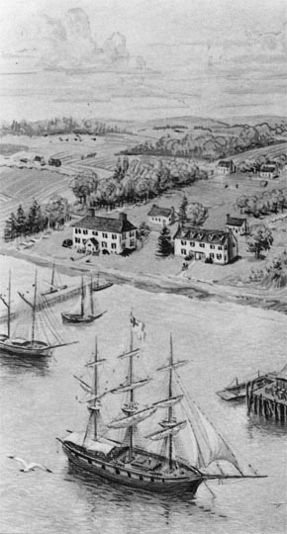

Bartholomew Vawter’s estate would have been very similar as it was located on the Rappahannock River. We know that he was a merchant and imported many items from England. He would have had a dock and warehouse to provide for these goods. In his will the listing of many, many bolts of fabric and other items were shown. His oldest son John inherited the estate and maintained the “rolling road” through his estate. This was a road to “roll” the large casks of tobacco down to the ships that were sent to England. He even maintained a tavern and inn for travelers. John’s youngest son, David, became the merchant of the family but the Revolutionary War interrupted the shipment of goods from England. David lost everything in his support of the war as did most of the plantation owners. They placed their lives and livelihood on the line. David became a guard and transporter of goods for the war effort and died during his service. The original land of Bartholomew was sold to the Garnett family in 1754 when John became too old to continue working, it remains in the Garnett family yet today located on the river down the road from the Vauter’s Church.

Page 7

What happened to the land of Bartholomew Vawter
in Essex County Virginia?

The estate of Bartholomew Vawter was sold to the Garnett family and is located down the dirt road beside the Vauter’s church of today in Virginia. Sold in 1754, the land has remained in the Garnett family all these years and are part of the plantation of today. After the purchase of the Vawter land a home was built called Mt. Pleasant. The History of Mt. Pleasant, gathered by Crystal Dingler:

Beginning in 1657, Capt. Thomas Hawkins (d. 1677) patented land on the south side of the Rappahannock River, Old Rappahannock County (present day Essex). He married Frances (NLN), and had two daughters and two sons. The land was inherited by his son, John Hawkins. He married Grace, widow of Samuel Stalled, and had two sons and two daughters. John sold the land to Bartholomew Voter ( Vawter) (d. 1717). Bartholomew married, in 1690, Winifred Hodgson. They had one daughter and five sons. On the death of Bartholomew, the land was inherited by his son, John. John married Margaret Noel, daughter of Daniel Noel and Elizabeth Elliott. They had two daughters and four sons.

In 1752, their son, Bartholomew, sold the property to Capt. James Garnett, Sr. (1692-1765), son of John Garnett, Sr., and his wife Anne, who came to Essex in 1690 from Gloucester County, Virginia. He erected a home there, and is probably the first to used the name "Mount Pleasant". James Garnett, Sr., married four times, and had four daughters and ten sons. By his second wife, Elizabeth Muscoe, daughter of Salvatore Muscoe and his wife Mary, he only had one son, Muscoe Garnett, Sr. (1734-1803). He inherited the property. He married on 7/9/1767, Grace Fenton Mercer (1750-1814), daughter of John Mercer, Jr., and Ann Roy, of "Marlborough", Stanford County, Virginia.

The house at Mount Pleasant" was described in the Mutual Assurance Society as "a dwelling house, 2-stories high, the walls of brick, covered with wood. 48 x 34 feet." The house sat on a promontory over 100 feet above the river valley. Muscoe and Grace F. M. Garnett had five daughters and five sons, including James Mercer Garnett, Sr. (1770-1843), for whom Muscoe built "Elmwood", Robert Selden Garnett, Sr., congressman and father of Brig. Gen. Robert Selden Garnett, Jr., the first Confederate or Union General killed in the Civil War, and John Mercer Garnett (1783-1856), who inherited "Mount Pleasant".
John M. Garnett never married, and on his death, left "Mount Pleasant" to his great-nephew Muscoe Russell Hunter Garnett (7/25/1821), son of James Mercer Garnett, Jr., and Maria Hunter. After his death, the house was closed, and soon destroyed. One source, Jimbo Gardner, states he remembers being told the house was shelled during the Civil War, and then torn down over time. Others accounts say the house burned.
Muscoe R. H. Garnett married on 7/26/1860, Mary Picton Stevens (1840-1903), daughter of Edwin Augustus Stevens, and they lived at "Elmwood". They had two sons, and one daughter. At the death of Muscoe R. H. Garnett, "Mount Pleasant" was left to his mother Maria Hunter Garnett, as was all his property, due to the fact their landholdings were so intertangled. In 1868, she sold it to her daughter-in-law, Mary P. S. Garnett. In 1895, she agreed to sell a right-of-way through "Mount Pleasant", to serve as new route for the road.

Page 8

The existing road ran directly by the churches west door, and, over the years, wagon wheels had rubbed against the bricks at the water level, and damaged the building. Access was granted, and the road was changed to run very near the path of the northbound lane of present day Rt. 17. This was granted on one stipulation. That none of the trees in the churchyard should be cut.
On her death, the property went to their only daughter, Mary "Miss Minnie" Barton Picton Garnett (1863-1949). She married on 5/31/1915, James Clayton Mitchell, of New Jersey. They had no children. In November of 1944, she sold the property to her niece, Virginia Garnett (1906-1973), daughter of her brother, James Mercer Garnett and Mary Virginia Teaton. Virginia Garnett married Thomas Blackburn Payne, MD (1908-1973), son of Robert James Payne, MD, and Anna Minor Blackburn. They had one son, Robert Mercer Payne (1935-1959), and two daughters, Virginia Blackburn Payne, and Mary Picton Garnett Payne. On the death of Virginia G. Payne, "Mount Pleasant" went jointly to the daughters.

Miscellaneous

This Vawter is not known to me but remember many state and territorial census were taken. If you don’t find your ancestor in the Federal Census try this idea. The US Census was destroyed for 1890 and these local censuses can be the only clue available to their location and ages.

1907 Oklahoma Territorial Census
Roswell K Vawter , Wolf Indian Territory, Seminole, OK Head of household b. ca 1854
Martha J. Vawter wife b. ca 1866
Joseph Vawter daughter b. ca 1888
Daniel K Vawter son b. ca 1886
Cordie M. Vawter daughter b. ca 1898
Alpha A. Vawter daughter b. ca 1891
Leonard L. Vawter son b. ca 1903

Now most documents and family information can be found on websites.
Here are a few you might enjoy looking at.
Even if you are not a genealogist, finding your family name in records is fun.

Fold3.com for military records
Archives.com for Census and other vital records
Newspapers.com for newspaper articles
Ancestry.com with over 32,000 data bases (some are free some require subscription, but all local libraries offer this free)
FamilySearch.org is the LDS website and is free, there are millions of documents and family trees.

Page 9

REMINISCENCES OF ARLETTA LEWIS UMMSETTER
(As Related to Deer Creek)
September 22, 1927

Read at the Deer Creek Homecoming.
Arletta Lewis was born in 1843 in a log cabin just east of the present farm home of Mrs. Nannie Gannon. She was a daughter of Charles and Charlotte Parks Lewis and her grandfather Alexander Lewis came from Virginia in company with John Vawter, founder of Vernon, in 1816. This Alexander Lewis had been married in Virginia to a Miss. LaFollette who died leaving him two daughters, Nancy and Sarah, one of whom became one of the county's leading women school teachers. On his way to Jennings Co., he married in Madison Miss Nancy Vawter, cousin of his companion, John Vawter, and to this union were born four children, Chas., David, Martha and Anna.
To follow you must think away the B.& O. Railroad, Federal road No. 50, and the Muscatatuck wagon bridge. Alexander Lewis took up his abode on the east side of the Muscatatuck and entered from the government the land now contained in the farms of Mike McGinty, J.E. Simmons, Mrs. Nannie Gannon, Pete Shuck, Bridget Wickens and part now owned by James Wickens and Wilber Gannon. Alex Lewis died in 1835, his wife twenty years later.
His children attended school at Vernon, and one incident related by her father stands clearly in Mrs. Ummsetter's memory. As Charles Lewis and his sister, Anna, were returning from school they saw a bear rearing upon its haunches sniffing up a tree trunk. The children stood motionless until Bruin finished his measuring and ambled on across the hollow after which they tiptoed quietly away from the spot and then ran home.
Mr. Chas. Lewis became the first constable of Vernon. He often obtained books from the county library at Vernon.
Mrs. Ummsetter attended her first term of school in a log cabin that stood just east of where Matt Wickens now lives which was then the Abercrombie place. This must have been old and without the customary loft for she recalls a child trying to pick up some shining object which proved to be only a spot of sunshine that fell through an opening in the roof. This school was in charge of John M. Grinstead. Her only text was a McGuffey's spelling book, no slate, blackboard, tablet or pencil. Her second term of school was passed in a large room that now forms the middle room of the W.T. Holsclaw residence. Here Lewis Whitcomb was the teacher. Mrs. Ummsetter recalls the proud day when the teacher promoted the class to the first reader. Her father went to the store at North Vernon and bought her book that evening. Imagine her disappointment next morning when the class assembled and the teacher said that as hers was the only reader, she must pass it on to the remainder of the class and the rest could get theirs Saturday. The next school was taught in the new frame building on the site where Vawter Feagler's house was later and in this building the remainder of her school years were spent until her father moved to Zoar. This latter building was moved and still stands on the Frank Knaub farm.
The children and families whom she recalls during the years of school life were as follows: Mary and Sarah Burns grandchildren of Wm. E. Vawter on Summerfield place, Frank, Irwin and Butler Huckleberry, lived on Wissel farm; George and John Carrol lived on same farm later; Taylor, Miles, Nancy and Almira McCaulou, on the Chaney farm; Tip, Charles, Sarah, Clarkson and two other sisters (later Mrs. Osborn and Mrs. Wagner), who lived on Mrs. Hannah Wickens farm; Ella and John Lovett, Mary and Anna Fitzgibbons on the Sasetter place, (the latter Mrs. Rosendoll, who died recently), and Anna Fitzgibbons daughter of Thos. Fitzgibbons who lived on the Nugent farm; Ellen ………………………………………………………………………………………………………….Page 10 and Edward Scanlon on McDonnel place; and Will and Almira King on present Cummins farm. The family of Mrs. Ann McCauley lived where the House sisters now live.
After Chas. Lewis had lived for a time on the present site of the Gannon farm he moved to the "big log house" consisting of two front rooms, an entry and kitchen which stood near the coffee-nut trees between Riley's cut and the RR bridge north of the track. When the B.& O.R.R. was built Mrs. Ummsetter recalls that a row of apple trees in front of the house that had to be cut down to make room for the track. The road was built in 1852, and when the first train consisting of engine and one car appeared, everyone ran out, to see it pass. But when the engineer blew the whistle the children scampered back into the house.
The Gannon land was sold to a Mr. Tate and within a year of the purchase a row of apple trees and a row of maple trees had been cut and made into cord wood. Think of the waste!
Things boomed while the road was a building, and to accommodate the workers, six shanties were built with Mr. Lewis permission on ground lying between the abandoned road thru Mrs. Gannon's farm and the creek bank. This was the period when the town of Clifton sprang up and threatened to outgrow N.V. This village was located on the Muscatatuck where the Simmons brickyard was later and had at one time the "big house" on the bluff where Mr. Harris, foreman, and his family lived, a store an office and a house occupied by Mr. Tate. One of the several shanties east of Mr. Lewis house was occupied by one Pat Riley which gave his name to Riley's cut. Pat Sharon and John Sharon lived with him, stepsons. The McGinty family bought the same land which Mike McGinty now owns. Sergt. John Corrigan of Indianapolis, lived in one of the houses of Clifton when it had ceased to be a boom town and the houses were rented for dwelling houses. Just west of the present Muscatatuck bridge may be seen traces of the old grist mill owned by Mr. Josiah Andrews.
An occurrence of this time illustrates the simplicity of the life of the time. A man was missing at a time when the water in the creek was frozen except for a tell tale hole in the ice. One morning when Mrs. Harrison looked out the window she saw to her horror a dead man raised in the water. She called others and they searched and found the body. A Mr. Sumpter made the coffin and they buried him along the creek bank further up.
This gathering. A Home-Coming, is tinged with sadness today as we realize our school house is gone and with it the traditions and experience of rural school life for what is taking place in Center Township has always taken place or will soon do so everywhere. The cycle seems to be completed, the sunlight filters through the roofs of abandoned schools elsewhere as here. Progress can not be stopped nor should we wish to do so. The present generation faces a different world and needs a different training than those of the past. We can only trust that these young people shall see and grasp the light as did that child in the log cabin school of old.

Funny Epitaphs

On Margaret Daniels grave at Hollywood Cemetery Richmond, Virginia:
She always said her feet were killing her but nobody believed her.
In a cemetery in Hartscombe, England:
On the 22nd of June- Jonathan Fiddle - Went out of tune.
In a London, England cemetery:Ann Mann
Here lies Ann Mann,Who lived an old maid
But died an old Mann.Dec. 8, 1767
Someone determined to be anonymous in Stowe, Vermont: I was somebody. Who, is no business of yours.

Page 11
GEORGIA DEPARTMENT OF ARCHIVES AND HISTORY, ATLANTA, GEORGIA 30334
The first part consists of the license to marry signed by the county ordinary or the clerk
of the Inferior Court and contains the names of the bride and groom and the dates.
Vaughter, James M.C. Stribling, M.J. 1870 W
Vaughter, James M.C. Stribling, M.J. 1870 W
Vaughter, Peter Holly, Martha 1871 C executory
Vaughters, Himer Williams, Sarah C. 1866 W
Vawter, Hiram Glenn, Elizabeth 1832 W
Adams, Absolum Q. Vaughters, Francis 1858 W
Allen, Matthew Vaughters, Lucinda 1829 W
King, George L. Vaughters, Julia 1867 W
Vandiver, William J.P. Vaughters, Eliza M. 1869 W
Wheeler, Russel J. Vaughter, Hepsey M. 1870 W

GEORGIA DEPARTMENT OF ARCHIVES AND HISTORY, ATLANTA, GEORGIA 30334
Also known as the Warrant files, these manuscripts reflect the various preliminary stages in the granting of headright land. In addition to a few other odd papers, the following types of documents are included in these files: warrants, vouchers, certificates, petitions, and powers of attorney.
95-2353A
33 (continued) 8053-17A
1783-1909 (continued), Buckelow, Frederick See: Smith, Francis; Buckhalter, Jacob; Buckhalter, John; Buckhalter, Joshua; Buckhalter, Micajah; Buckhalter, Michael; Buckhalter, Vaughter; Buckhalter, William See: Coram, William
95-2353A
242 (continued) 8059-13b
1783-1909 (continued); Vaughter, Whorton; Vaughters, Hiram
95-2353A
145 (continued) 8057-01a
1783-1909 (continued); Maguire, Alligany

This series contains unbound original miscellaneous records of the Superior Court of Franklin County.
00-1057A 3 (continued) 1902-15
1833 (continued) Parr, Mathew (for use of John R. Stanford) vs James Vaughters
1835 Allen, William vs James Vaughters
Faulkner AR County Probate Records
Genealogical Data
Probate Records
File 48─ Bennett, P. E (Estate) – died May 24, 1878
S. H. Vaughter – Guardian of William W. Bennett
Guardian bond dated July 15, 1878.
Heir: Sophia L. Bennett (widow)
File 51─ Bennett, W. W (Estate) – died April 26, 1881
J. M. C. Vaughter – Administrator
Administrator bond dated July 23, 1884.
Heirs: Martha E. Earle and James L. Tarkinson (no widow)

News items from Jan 26 1915 Montgomery News - Montgomery County, Illinois
The Montgomery News, Tuesday, January, 26, 1915 page 8 columns 1-4
-The Enterprise Society of the M.E. church will meet Wednesday afternoon with Mrs. John and Mrs. Jane Vawter

1823 New Orleans City Directory Orleans Parish, LA
Vawter George M. com. merchant commionnaire

Dedicated to finding Vauter(s), Vawter(s), Vaughter(s)
Newsletter
June 2016 Volume 40 No 2
Reunion Dates:
Bentonville, Arkansas July 14-17, 2016
San Antonio Texas July 13-16, 2017
Central Indiana July 2018

Website: www.vawterfamily.org
Officers
President Bruce Vawter, 9321 Manoroak Dr, St. Louis, MO 63126
Phone 314-849-8727 email fcsvawter@sbcglobal.net
Vice President Darren Welch, 402 N Galeston Ave, Indianapolis, IN 46229
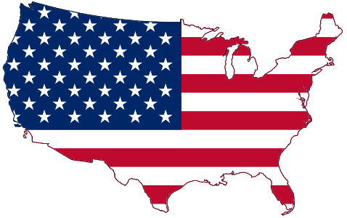
Phone 317-899-1992 email: Darren.welch@cnoinc.com
Treasurer Jordan M. Johnston…14357 W. Lexington Ave,
Goodyear, AZ 85395 Phone 903-624-9632 email Jordan@bearcreekindustries.com
Asst. Treasurer Phil Vaughter…1103 Newport, Austin, TX 78753
Phone…512-836-3105 email PRV37@aol.com
Secretary Rebecca Guinagh, 7805 NW 28th PL Apt M101,
Gainesville, FL 32606,
Phone 352-331-2879. Email Guinaghbeck@yahoo.com
Archivist Beth Melton, 3809 Junker, Rosenberg, TX 77471
Phone 281-232-7972 email - emeltonea@aol.com
Newsletter & Georgene Jurgensen…8408 Mohican Ave
Historian Brooksville, FL 34613
Phone…816-591-0251 email gfjurgensen@gmail.com
Website & Patricia Renton…2372 Bear Creek Rd, Pipe Creek, TX 78063
Newsletter Phone…830-510-4625 email pvrenton@gmail.com

Now is the time to make reservations for the July reunion.

Doubletree Suites by Hilton Hotel Bentonville

301 SE Walton Blvd
Bentonville, Arkansas, 72712, USA

GROUP CALL IN: 479-845-7770
GROUP CODE: VVV

Or ONLINE BOOKING LINK HOTEL:

http://doubletree3.hilton.

com/en/hotels/arkansas/doubletree-suites-by-hilton-hotel-bentonville-BNTDTDT/index.html

The Room Rate is $119 for Thursday night and $94/night for Friday and Saturday.
The Double Tree has a restaurant and our breakfast is included in the Room Rate!
Saturday night dinner will be $30/person

Mobridge, SD police history, including John G. Vawter, Jr.

Mobridge was not much different in law enforcement problems from any other frontier settlement when
the town sprang up around 1906. And its marshals and constables, who enforced the early-day laws,
gradually evolved into today's police force.
Bert Dekker was one of the earliest known peace officers in Mobridge, teamed up with A. E. Flick, who was a justice of the peace. The first person ever arrested in the new town in 1907 was a cowboy who rode his horse into one of the four "blind pigs" (a term used in the early 1900s for a bar or lounge) that were operating in Mobridge before the sale of liquor became legal.

The cowpoke was fined five dollars, with Dekker, the arresting officer, and Flick, the J.P., splitting the fine, as was customary in frontier towns. That partnership between law and order, typified by the justice and the cop, helped maintain decorum in a community which tended toward disregard for the law.

Each blind pig had an orchestra playing every night, including Sundays, while most of them had gambling halls in the rear - with dice, roulette, poker and Black Jack tables. On pay days, the town swarmed with workers out to live it up and those were the only days when the lone policeman would be busy.
"Burglars battered up the door of Comstock's warehouse last evening in an attempt to gain entrance, but failed," reported the Mobridge News on July 29, 1910. "If such things are going to become common, someone will have to begin to agitate things so we will have a night police."

Whether or not this comment served as the impetus, a "night watchman" empowered with police

Page 2

functions thereupon went on duty. "Revenuers" - Mobridge-style - are these representatives of law and order, around 1917. The kegs seen in the foreground of the picture to the left had been seized as evidence in an illegal liquor trafficking deal, and their contents poured off forthwith. The only upshot of that deed was that the case was thrown out of court for lack of evidence. Seen in the photo, left to right, are Chief of Police Dan House, Captain Guy P. Squires, Chaplin of Camp Pontis (and guiding light behind the establishment of the "Mobridge Purity League"), Judge J. G. Vawter, and Police & Fire Commissioner Orson Clark.

Lincoln County Missouri Genealogy Trails
COLONEL VAWTER, a native of Lincoln County, Missouri, was born January 26, 1867, being a son of William and Matilda Vawter. He was married June 07, 1896, to Ida M Rahe, daughter of John and Rebecca Rahe. They have one child- Emil Rahe Vawter, born October 14, 1898. When only a few months old, Mr. Vawter moved with his parents to Shelby County Missouri, later to Kansas where they remained over two years. They then came to Adair County Missouri, settling here in 1899, where Mr. Vawter has since lived. He is engaged in the blacksmith and wagon-making business at Brashear, and has followed that occupation continuously since grown. Mr. Vawter is a member of one of the oldest families in the United States and England, many of them being prominent in public life and the commercial world. A history of the Vawter family, running back to 1016, has been placed with the Missouri State Historical Society. He is a member of the Christian church, the Masonic, Odd Fellow and Modern Brotherhood of America fraternities, and the Republican party.
[Source: "A History of Adair County Missouri" by E.M. Violette (1911). Submitted By Desiree Rodcay]

Tuesday, January 9, 1951

Edmund R. Vawter
Edmund R. VAWTER, 76, life-long resident of this city, passed away at 11 a.m. today at his home 502 North Jefferson street. Death was attributed to a cerebral hemorrhage which he suffered around noon Sunday.
At the time of his death he was serving as a member of the board of trustees of the Rochester City Waterworks, an office which he had held since 1938. Mr. Vawter had a wide acquaintance of friends throughout Rochester and surrounding community.
Edmund Ramsey, son of Benjamin and Sarah VAWTER, was born in Rochester on Aug. 14, 1874. On June 6, 1900, he was married to Minnie D. HOSTEDLER at Chicago. For a long number of years he owned and operated the Rochester Steam Laundry and retired from that business several years ago.
Mr. Vawter was a member of the Trinity Evangelical United Brethren church of this city and served as a Sunday school teacher for 45 consecutive years. He was also a trustee and an official of the administrative council of the church. Mr. Vawter was also a member of the Masonic and I.O.O.F. lodges of this city.
Survivors are his wife, at home; two daughters, Mrs. Irving TARRANT, Hinsdale, Ill., Mrs. Robert FISHER, of this city; four grandchildren, Gordon NORRIS, Alicia, Pamela Lisbeth, and Phoebe TARRANT, and two sisters, Mrs. Harley WOODCOX, of this city, and Mrs. Archie WOODFIELD, of Indianapolis. A daughter, Mrs. Miriam ALEXANDER, preceded him in death.
Funeral services will be held at 2 p.m. Thursday, Jan. 11, at the Trinity Evangelical United Brethren church with the Rev. Stephen GUBI officiating. Burial will be in the Rochester I.O.O.F. cemetery.
The body will be at the Foster funeral home until noon Thursday and will lie in state at the church from noon until the hour of the services.

Page 3
Leonard F. Vawter of Kansas

From the book “Vawter Family in America” by Grace Vawter Bicknell published in 1905 the lineage of Leonard Franklin Vawter is found. He is listed as a child of James Elliott Vawter the ninth child of Jephtha D. Vawter.

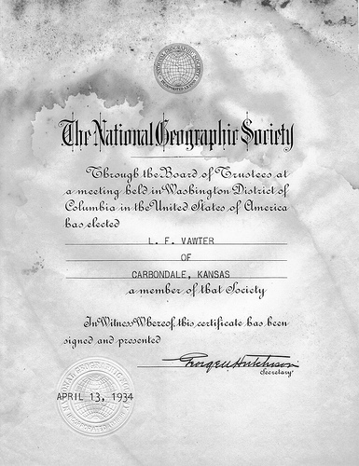
(9) James Elliott, son of Jephtha D. and Sarah (Foster) Vawter. was born in Todd county, February 21, 1847: married February 17, 1874, at Tremont, Illinois, to Mary E. Huxtable who was born at Deer Creek. Illinois. February 26, 1855.

James E. Vawter died at Fountain, Kansas, June 6. 1899.

Children :
a. Anna Belle, daughter of James E. and Mary (Huxtable) Vawter, was born June 28, 1879; died September 28, 1879.
b. Sarah Ellen, daughter of James E. and Mary (Huxtable) Vawter, was born March 11, 1881; married August 16, 1899 to F. A. Newman in Topeka, Kansas. Children : An infant, born August 15, 1900: died September 7, 1900. and Harold Anson Newman, who was born September 19, 1901.

c. George William, son of James E. and Mary (Huxtable) Vawter, was born October 21, 1885.

d. Leonard Franklin, son of James E. and Mary (Huxtable) Vawter, was born December 31, 1889.

c. Stella May, daughter of James E. and Mary (Huxtable) Vawter, was born June 16, 1887: died November 1, 1890.

e. Leslie Wayne, son of James E. and Mary (Huxtable) Vawter, was born August 4, 1894.

Mrs. Mary Vawter and family live near Carbondale, Kansas.
Page 4

Obituary of Leonard F. Vawter Dies at Carbondale
Services were held at the Burlingame Federated church, Monday for Leonard F. Vawter, 79, who died Feb. 22, 1969 at his home near Carbondale. Burial was in the Burlingame cemetery. Mr. Vawter was born Dec. 31, 1889, in the Fountain Ridge neighborhood west of Carbondale and has spent most of his life there. He was a retired farmer. He was married to Eva Herold Nov. 20, 1919. Besides his widow, he is survived by a daughter, Mrs. Wilma Kneale of rural Topeka; two sons, Robert D. of rural Carbondale and Harold E. of Topeka; a brother, Leslie of Burlingame; ten grandchildren and a step-grandchild.

OSAGE COUNTY, KANSAS 1879 PATRONS LIST

Source: 1879 Osage County, Kansas Atlas By: Edwards Brothers Transcribed by Charlotte Slater

Vawter, J.D. Waveland KS

TOWN 13 SOUTH. RANGE 15 EAST OF THE 6TH P.M. Section 33

Farmer / Stock Raiser Todd Co Kentucky Settled in 1868

FULTON COUNTY INDIANA OBITUARIES 1971 The Rochester Sentinel
Wednesday, August 25, 1971 Minnie D. Vawter
Mrs. Minnie D. VAWTER, 95, 502 Jefferson street, died at 5:50 a.m. today at her residence.
Born April 19, 1876, in Rochester, she was the daughter of Eli and Emmeline LANTZ HOSTEDLER. Her marriage was June 6, 1900, in Chicago, to Edmond R. VAWTER. He preceded in death Jan. 9, 1951. She had resided the majority of her life in this community and was a member of the Trinity United Methodist church. She was also a member of the WSCS of the church and the Eastern Star.
Surviving are two daughters, Mrs. Robert (Helen) FISHEL, Rochester, and Mrs. Irving (Alice) TARRANT, Hinsdale, Ill.; five grandchildren; two great-grandchildren. A daughter, Mrs. Miriam [ALEXANDER] preceded in death.
Final rites will be at 2 p.m. Friday in the Foster & Good funeral home. The Rev. Vernon A. LALLEMENT will officiate. Burial will be in the I.O.O.F. cemetery here. Friends may call at the funeral home after 4 p.m. Thursday

Gleanings from "The Kinmundy Express" 1951 Compiled by Dolores Ford Mobley, Springfield IL
Nov 15, 1951 - Mrs. Charles FOX spent Tuesday evening in Salem as a guest in the home of Mr. and Mrs. Homer KEELER. They were entertaining 22 guests to a turkey dinner for 3 birthdays in their family; that of Mrs. KEELER’s father, Fred W. MERRITT; her aunt, Mrs. Anna VAWTER; and her niece, Mrs. Fred (Bud) MERRITT.

Page 5
Activities planned for the July reunion in Bentonville, Arkansas
Thursday July 14th
Thursday, July 14th 6pm-8pm: BBQ Welcome dinner at the home of Chad and Denise Bugos. 4125 Caerleon Circle Bentonville AR 72712. Gated Subdivision. Swimming will be the main activity; please let everyone know that we have a pool and would like for anyone who wants to swim to bring swimsuits.

Friday July 15th
Friday, July 15th 10am-12noon: Crystal Bridges Museum of American Art (http://crystalbridges.org/). 600 Museum Way Bentonville, AR 72712 Right now we are set-up for a Free Self-Guided Tour. They will give us devices that we can use for an audio tour. There is a guided option for $10/person.

Friday, July 15th 10am-12noon: For Families with children ages 4-9 in mind: Scott Family Amazeum Children’s Museum(http://www.amazeum.org/). 1009 Museum Way Bentonville, AR 72712 (Right in front of the Crystal Bridges Museum. Admission price is $9.50 for guests ages 2 and over. Children under 2 will be admitted free.

Friday, July 15th optional lunch: Flying Fish (http://www.flyingfishinthe.net/Bentonville.php)
109 NW 2nd St, Bentonville, AR 72712. Average price: $10-$15/person. They do have kid’s meals that are unique and very reasonably priced.

Saturday July 16th
Saturday, July 16th 7:30am-1pm optional tour: Bentonville Farmer’s Market (http://www.downtownbentonville.org/#!farmers-market/rkmm7). Located on the Bentonville Square, Downtown Bentonville. FREE – unless you buy a bunch of stuff! We will be in this area on Friday for Lunch at the Flying Fish, so everyone will know where it is located.

Saturday, July 16th 8am-10pm optional tour: The Walmart Museum (http://www.walmartmuseum.com/visit/5-10/). 105 N. Main Street Bentonville AR 72712.
FREE admission.

Saturday, July 16th 10am-12noon optional tour: Pea Ridge National Military Park (http://www.nps.gov/peri/index.htm). 15930 E Hwy 62 Garfield AR 72732. Cost: $15.00 per vehicle –
The pass is valid for 7 days.

Saturday July 16th 10am-9pm optional Family Fun: High Rise Trampoline Park “Open Jump” (http://www.highrise.us/). 4699 S. Dixieland Rd., Rogers, AR 72758. Cost: Age 6 & under: $10 –
1 hour flight ticket; Ages 7+: $13 – 1 Hr flight ticket. Walk-ins are always welcome, however we recommend purchasing flight tickets in advance in order to guarantee your flight! To purchase tickets, please click our “Tickets” tab. Remember, All who enter must sign a waiver. All participants under the age of 18 must have it signed by a parent or legal guardian. To streamline your check-in process, you may sign online by clicking our “Waiver” tab. Flights take-off every ½ hour, so please arrive 15 minutes early to prepare for lift-off. Anyone under the age of 13 must be accompanied by an Adult. Remember, you may only participate barefoot, or with our gripper socks for optimal traction

Page 6

2016 REUNION SCHEDULE

Thursday, July 14

3:00 p.m. – 5:30 p.m……………………………………………....……….Registration
6:00 - 8:00p.m………………………………........................................Welcome dinner
8:30 p.m……………………………………..………….Executive Committee Meeting

Friday, July 15
Complimentary Breakfast
8:30 – 9:00……………………………………………………...…………...Registration
9:00………………………………………………………………..…..Business Meeting

Welcome - Ringing of the Cowbell – Invocation- Pledge - Official Welcome
Preliminary Registration Report - Preliminary Site Committee Report - Other Business

10:00 – 12:00…………………………………………………Crystal Bridges Museum

Optional lunch at the Flying Fish

6:00 p.m………………………………………………………...…Dinner on your own

Saturday, July 16

Complimentary Breakfast

7:30 – 1:00 p.m……………….……..Optional tour of Bentonville Farmer’s Market

………………………………….…………Or optional tour of the Walmart Museum

………………………………..Or optional tour of Pea Ridge National Military Park

Noon……………………………………………………………………………….Lunch

6:00 p.m…………………………………..……………………….……………Banquet

Invocation – Dinner - Memorial Service - Love Offering for Vauter’s Church
Special Recognition –Youngest, Oldest, Longest Married - Roll Call of States

Invitation to 2017 Reunion - Door Prizes – Auction - Adjournment

For additional information or questions please contact:
2016 Host Contact Info: Chad and Denise Bugos 4125 Caerleon Circle Bentonville AR 72712 chadbugos@gmail.com

Page 7

Descendants of John Pitts, Contributed by Lucius F. Wright, M.D. © 2007

1. JOHN1 PITTS was born before 1670 Old Rappahannock Co., Virginia, and died before 15 September 1730 Essex Co., Virginia.

Children of JOHN PITTS are:

+2. DAVID2 PITTS, b. about 1700 Essex Co., Va., d. before 20 October 1783 Essex Co., Va.

3. JOHN2 PITTS, b. about 1700 Essex Co., Va.; m. MARY _____.
David Pitts is mentioned in his father’s will, which indicates that he has moved from his former “plantation.” This will also establishes that he had a son, presumably his eldest, named John.

The poll list recorded 20 November 1741 indicates the presence and voting of David Pitts, John Pitts, and John Pitts, Jr. It seems likely that the “John Pitts, Jr.” is the eldest son of David Pitts, meaning he was born 1720 or before. This, in turn, implies that David Pitts was likely born before 1700. Additional support for this is found in a deed from 14 Jan 1721/22, in which Richard Long of St. Mary’s Parish sold a tract of land to Timothy Swilevan (Sullivan?) on Long Bridge Swamp adjacent to David Pitts, Jno. Harrison, and Job Spearman. Witnesses were Buchenmn. Browne, John Spearman, and Jno. Vawter, so this property is likely in the neighborhood of John Pitts. Since David Pitts was recorded as owning land, he was at least 21 years old. David Pitts was still in this area in 1731, when Thomas Reynolds sold a tract of land to John Clement on Blackburn’s Creek, John Hawkins, Samuel Stallard, Robert Parker, David Pitts, and Timothy Swilevan.

On 19 March 1738/39, David Pitts of Essex County purchased a tract of 100 acres from John Hart of Caroline County for £23 “current money.” This tract was described as land purchased by William Hart, uncle of John Hart, from Robert Paine, and bounded by the land of Job Spearman, James Daniel, and John Harrison. Witnesses were Robert Parker, Edmund Carroll, and Thomas “Swillivant.” This suggests the property was near to, although not adjacent to, land already occupied by David Pitts.

David Pitts, Sr. is in the DAR Patriot Index for Patriotic Service in Virginia.

The last will and testament of David Pitts was written in Essex Co., Va., on July 20, 1780, and proved October 20, 1783. This will was signed by a "P." He names his sons Lunsford and David Pitts as his executors. There are no provisions in this will for a wife, so she is presumed to have died prior to 20 July 1780. Lunsford Pitts appears to be the youngest son, and perhaps the youngest child. Data to be presented later suggests his birth occurred about 1750, which establishes the early estimate for the period of her death.

Page 8

Children of DAVID PITTS are:

4. JOHN3 PITTS, born before 1728 Essex Co., Va.; d. Caroline Co., Va.

5. THOMAS PITTS, d. 1806 Essex Co., Va. ; m. MARY _____.

6. TABITHA PITTS, m. _____ CARNAL.

7. JOSEPH PITTS.

8. DAVID PITTS, died 28 Aug 1792 Essex Co., Va.; m. SARAH JOHNSON.

+9. LUNSFORD3 PITTS, b. about 1751 Essex Co., Va., d. 1813 Sumner Co., Tenn.

10. SUSANNA PITTS, m. _____ ELKINS.

11. MARY PITTS, m. _____ CONDIT.

12. HANNAH PITTS, m. _____ HOLLAND.

13. ELIZABETH PITTS, d. 1796 in Kentucky; m. THOMAS VAWTER about 1765 Essex Co., Va., son of EDWARD VAWTER and ELIZABETH BOULWARE.

David Pitts’ will establishes that his daughter had married Mr. Vawter. A family history of the Vawter family suggests that his name was Thomas Vawter, son of Edward Vawter.

However, the information about Elizabeth Pitts’ father does not match the information contained in the record. A family record written in 1860 by Dr. William B. Harrison, son of Mary Vawter Harrison stated:

“Far back in Colonial days there came to this country one Vawter. He had a son, Thomas, who received a liberal education in the schools of the old world. He was appointed Government Surveyor about the time Geo. Washington received a similar appointment. Thomas was surveying in Montgomery County near the spot of the famous Sulphur Springs when he became enamored of a Miss Elizabeth Pitts who had just reached this country from England. Her father was a wealthy aristocrat who came over with a fleet of his own. He opposed his daughter’s marriage with young Vawter simply because the young man was poor…and the young couple eloped. The old gentleman afterwards realized the sterling worth and business ability of his son in law and they were reconciled and lived most happily together.”

Edward Vawter, father of Thomas, witnessed the indenture whereby John Pitts, the younger, sold the land in Essex Co., Va., that he had inherited from his grandfather, John Pitts. (see above, Essex Co Va., Deed Book 24:289.) While it is possible that Thomas Vawter married an Elizabeth Pitts from an unrelated family, it seems unlikely to me. How much of the Vawter family legend is true regarding the activities of the Pitts family is likewise uncertain.

Page 9

In Memoriam

MARK HUDSON, Sherman - Richard Mark Hudson, 56, passed away Thursday, February 25, 2016, at his home. He was born in New Albany on July 1, 1959 to Thomas and Martha Mayer Hudson. He was in the United States Navy from 1981 until 1987 as a support mechanic. Mark worked at Pepsi Co. as a forklift operator for 15 years until he was prevented from work for health reasons. He was a member of Sherman Church of Christ and a volunteer firefighter. Services will be 2 p.m. Saturday, February 27, 2016, at the Jefferson Street Chapel of W. E. Pegues with Minister Joe Connell officiating. Burial will be in Glenfield Cemetery in New Albany. Survivors include his wife, Margaret Hudson; daughter, Jacqueline Smith (Brandon); sons, Ryan Shipley and Thomas Hudson all of the home; mother, Martha Hudson; brothers, Jerry Hudson (Kay) and Michael Hudson (Lisa); grandchildren, Ian Smith and Corinne Smith; numerous nieces and nephews. He was preceded in death by his father, Thomas Durl Hudson, grandparents, Leford and Ethel Hudson and Thurman Emery and Clarice Vawter Mayer. Pallbearers will be Dennis Gable, Corey Holland, Brandon Smith, Tommy Hudson, Larry Grissom, John Kitchens and Chris Hale.

Norma Jean Vawter passed away on February 26, 2016 in Memphis, TN. She was born in Milan, TN on July 17, 1932 to Floyd Lynn and Seeley Anne Moore Lowery. She attended her beloved Milan High School where she was a cheerleader and basketball player. Mrs. Vawter was a member of the First United Methodist Church. She was an avid Milan Bulldogs and Lady Vols fan and over the years attended many of their games. Along with her parents, she was preceded in death by her husband of 46 years, Robert Marshall “Pete” Vawter and a little brother Sammie Moore “Buddy” Lowery. She is survived by a daughter Barbara Vawter Rothrock (Dr. Perry) of Memphis, a son Robert “Bobby” Vawter (Janet) of Lakeland, TN, a brother Lynn Lowery II (Dale) of Germantown, her grandchildren Wendy Lawson (Richard) of Milan, Dr. Emily Joyce (Tyler) of Lewisville, NC, Katelyn Vawter of Lakeland, Jake DeFur of Seattle, WA and Andrew Vawter (Sarah) of Whidbey Island, WA, eleven great grandchildren and a niece and nephew.

Dorothy Vawter passed away on February 21, 2016 just days away from her 80th birthday.
Dorothy was born February 26, 1936. She was married to Richard Woods Vawter. He preceded her in death in 2007. Richard and Dorothy attended many VVV reunions, starting in 1996. She continued to attend after Richard passed, including the 2015 reunion in Virginia. Dorothy was a very special lady and will surely be missed.
A tribute was held Sunday, April 10, 2pm, Plaza Jewish Chapel, 630 Amsterdam Ave., New York, NY

Ruth L. Vawter, 98, passed away at 11:10 a.m. February 29, 2016 at Lima Convalescent Home. Ruth was born December 28, 1917 in Circleville to Thomas and Anna Mae (O'Hara) Moodispaugh who preceded her in death. On June 20, 1936 she married John Arthur Vawter who preceded her in death on November 16, 1985. She retired as a beautician from LeTigress Salon. She enjoyed cooking and baking, especially pies. Survivors include three daughters, Beverley Baker of Columbus, Barbara Forest of Lima, Thelma (Ronald) Breech of Covington, GA; 14 grandchildren; and several great-grandchildren. She was preceded in death by a son Lawrence Vawter, seven brothers and sisters.

Virgil R Weidner, 99, formerly of Medway, OH passed away on Thursday, March 31, 2016. He was born February 20, 1917 in Cooksville, IL the son of the late George and Lula (Vawter) Weidner. Virg was an Electrical Engineer at Wright Patterson AFB for 34 years. In addition to his parents he was preceded in death by his loving wife of 69 years, Aletha (Cable) Weidner and his brother, George Clifford Weidner. He is survived by his 5 children, Jerry (Luba) Weidner, Lee (Cathy) Weidner, Don Weidner, Becky (Dale) Frost and Linda (Woody) Davis; 7 grandchildren and 6 great-grandchildren.
Page 10

Dedicated to finding Vauter(s), Vawter(s), Vaughter(s)
Newsletter
September 2016 Volume 40 No 3
Reunion Dates:
San Antonio Texas July 13-16, 2017
Central Indiana - July 2018
Kansas – July 2019

Website: www.vawterfamily.org
Officers
President Darren Welch… 402 N Galeston Ave, Indianapolis, IN 46229
Phone 317-899-1992 email: Darren.welch@cnoinc.com
Vice President Robert L Vawter….3773 Piper Bay LN, Lakeland, TN 38002
Email - Vawter.bob@gmail.com
Treasurer Jordan M. Johnston…14357 W. Lexington Ave,

Goodyear, AZ 85395 Phone 903-624-9632 email Jordan@bearcreekindustries.com
Asst. Treasurer Phil Vaughter…1103 Newport, Austin, TX 78753
Phone…512-836-3105 email PRV37@aol.com
Secretary Michelle Alexander….489 Nannie Neal Rd, Hardin,
KY 42048 email – mrax3@juno.com
Archivist Beth Melton, 3809 Junker, Rosenberg, TX 77471
Phone 281-232-7972 email - emeltonea@aol.com
Newsletter & Georgene Jurgensen…8408 Mohican Ave
Historian Brooksville, FL 34613
Phone…816-591-0251 email- gfjurgensen@gmail.com
Website & Patricia Renton…2372 Bear Creek Rd, Pipe Creek, TX 78063
Newsletter Phone…830-510-4625 email -pvrenton@gmail.com

First Presbyterian Church of Santa Monica, California
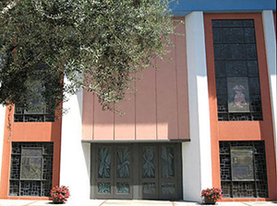
The First Presbyterian Church of Santa Monica was founded by two sisters, Emma and Jennie Vawter, who wanted a safe place for the children they saw “running wild” on the beach. They created a Sunday school in their home, and the church grew from there.

The Church was officially chartered on September 28, 1875, with nine women and three men as charter members. In keeping with the Presbyterian emphasis on education for all, the first building also served as the public school for several years. A newer building followed in 1889, and the congregation grew along with the city of Santa Monica.

In 1922, the church built a large and dramatic Spanish Renaissance structure. The congregation moved into its current location on 2nd Street in Santa Monica in 1975. We completed an extensive remodeling in April of 2007. Through the years, FIRST PRES has consistently emphasized family, education, music, and involvement in the social issues of the day.

In Memoriam

Leslie Ann Vawter of Mountain Home, Arkansas, passed away March 28, 2016, at the age of 49. Leslie is survived by her husband of 30 years, Michael Vawter; son, Jon Vawter; daughter, Kate Vawter and mother, Nan Weaver all of Mountain home, AR; brother, Eddie (Kim) Weaver and their children, Ross and Peyton of Bryant, AR and Alexandria (Dane) Duffield of Stuttgart, AR; aunts, Jean Pennel of August, GA; Ben Dean Malone of Memphis, TN, Sandy (Wilson) Holman of Charlotte, AR and Jean Weaver of Newport, AR as well as a host of family and friends. Leslie was preceded in death by her father, Ed Weaver.
Leslie graduated from the University of Central Arkansas at Conway with a degree in English/Library and taught in several Arkansas schools. Being a librarian, Leslie loved books and reading was her favorite pastime.
After moving to Mountain Home, in 1996, Leslie and Michael purchased Razorback Office Supply and Twin Lakes Supply. In 2008, they constructed a new building and combined both companies into Supply Solutions and later added the Mountain Valley Spring Water distributorship. Leslie was a vital asset to their business until cancer caused her health to decline and she was unable to continue.
Leslie was known and loved for her beautiful smile. She was a patient at the Hospice House from December 2015 until her death where she was treated with excellent loving care. Even though she was very ill and in severe pain, she would greet any person who came into her room with her angelic smile.
Funeral Services will be 11:00 am, Saturday, April 2, 2016, at Gassville Baptist Church, with Reverend Gary Wise officiating. Burial will follow at Kirby's Tucker Memorial Cemetery, Tucker Cemetery Road, Mountain Home, AR. Pallbearers will be Layton Lee, Mike Willard, Dr. John Sullivant, Matt Brown, Ross Weaver and Jon Vawter. Published in Baxter Bulletin

Funeral services for Luther Vawter, 96 of San Antonio, formerly of Early, will be held at 10 a.m. Thursday, May 26, 2016 in the Heartland Funeral Home Chapel. Burial will follow at Eastlawn Memorial Park. Visitation will be held from 6 to 8 p.m. Wednesday at the funeral home. He died Saturday, May 21, 2016 in San Antonio.

Don Jerrell Vawter, 85, Russiaville, passed away at 8 p.m. on Thursday, May 26, 2016, at Wellbrooke of Kokomo. He was born February 20, 1931, in Kokomo, to Ray and Emma (Stewart) Vawter. On May 20, 1951, he married Annabelle Sellers, at Liberty Baptist Church, and she survives.
Don graduated from Prairie Township High School in 1948. He worked at Reliance Manufacturing Company before being drafted into the military and served as a paratrooper with the 82nd Airborne Division from 1951 to 1953. He then attended Kokomo Business College, graduating in 1955, and worked as office manager/bookkeeper for more than forty years for Murray and Davis Incorporated, retiring in May of 1995.
He was a member of West Point Christian Church since 1955, where he previously served as an elder, deacon, treasurer, board chairman, Sunday school superintendent and teacher. He was also a member of U.C.T. since 1957 and the Ancient Order of Bagdad and was a former Prairieville Cemetery Board Chairman.

Page 2

In addition to his wife, Annabelle Vawter, he is survived by his five children, Michael Vawter, Susan Vawter, Karen (Glenn) VanMeter, Kristi Bledsoe and Katrina Vawter; eight grandchildren, Sandy McQuinn (Brian Pigott), Amanda Vawter (Jeff Watkins), Matt (Denee) Vawter, Michael J. Brown, Tyler (Meredith) VanMeter, Tori VanMeter, Anyssa VanMeter and Jake Bledsoe; five great-grandchildren, Brayden Pigott, Annalee Watkins, August Watkins, Marley Vawter and Malayah Vawter; two sisters, Wilma Huse and Sharon Brock; three sisters-in-law, Rosina Vawter, Anita Kessler and Linda Kessler; one brother-in-law, Donald Gene Sellers; and several much loved nieces, nephews and cousins.
He was preceded in death by his parents; grandparents; four brothers, Farrell Vawter, Doyle Vawter, two infant brothers, Milburn Ray and Ned Vawter; one sister, Bertonna Pumphrey; three brothers-in-law, Dewayne Pumphrey, Bill Huse and Earl Brock; and several aunts and uncles.

Vawter, Bruce Passed away Wednesday, July 6, 2016. Beloved husband of Linda Vawter. Dear father of Kenneth Vawter, Lori (Scott) Shepherd and Jason Vawter; dear grandfather of 5 and great-grandfather of 3; dear brother of Shirley (Jerry) Beasley, Wayne (Carole) Vawter, Roger (Margie) Vawter and Gary (Penny) Vawter; and dear uncle, great-uncle, cousin and friend to many.
Services: Visitation at KUTIS AFFTON CHAPEL 10151 Gravois Rd., Friday, July 8, 4-8 p.m. Private Interment.
In lieu of flowers contributions to Boy Scouts of America or Maplewood United Methodist Church. A celebration of life will be held on Saturday, July 9, 3:30 p.m. at Sunset Hills Community Center 3915 S. Lindbergh Blvd., Sunset Hills, MO 63127. Bruce was currently serving as the President of the VVV family organization at the time of his death. He will be missed by one and all.

Joseph Edward Welch, 76, of Scipio passed away at 1:20 p.m. on Wednesday, July 27, 2016 at his residence. Born 13th of October 1939 in Geneva Township, Jennings County; Mr. Welch was the son of the late Clarence Ed and Mary Olive Taylor Welch. He married Bonita Fern Taylor on 19th of September 1959 at the First Baptist Church in North Vernon; she survives.
Mr. Welch was employed with Cummins Inc., for 31 years, retiring as a welder on March 31, 1990. He had worked part time as a welder for Miller Enterprises and retired from farming. Mr. Welch was a 1957 graduate of North Vernon High School and a member of Bethel Baptist Church in North Vernon and the Jennings County Republican Party. He enjoyed following the stock market, lunch with friends after church on Sunday, attending events at the Park Theatre Civic Centre and reunions of the Vawter Family Association. He collected mechanical and iron banks. As a woodworker, he had a special talent for making band saw boxes. He dearly loved his family and was proud of their accomplishments.
Survivors include his wife, Bonita F. Welch of Scipio; sons, Anthony Brian Welch, Darren Michael Welch and Alan Wayne (Yu Kyong “Karen”) Welch all of Indianapolis; grandchildren, William Frederick Welch, Jonathan Andrew Welch and Anna Louise Swenson all of Indianapolis; sisters, Janet H. (John) Jones of Scipio and Marylynne Sharp of Seymour. He was preceded in death by his parents and a son, David Brent Welch.
A funeral service for Mr. Welch will be conducted at 11:00 a.m. on Saturday, July 30, 2016 at Dove-Sharp & Rudicel Funeral Home and Cremation Services with Bob Ochs and Brother Ricky Persons officiating. Burial will be in the Vernon Cemetery in Vernon. Joe, his wife Bonita and family have been long time VVV family members and have served in many capacities with the organization. He will be missed at the annual meetings.

Page 3

The 40th VVV Family Reunion July 2016 Bentonville, Arkansas.
Lots of great fun and entertainment at the reunion this year. Thanks to Chad Bugos for his hard work in setting up all the tours and food.

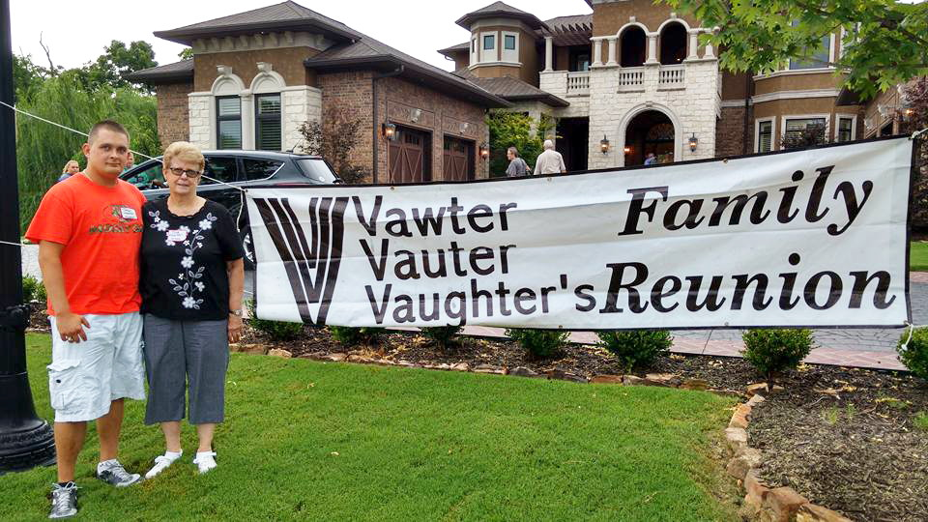

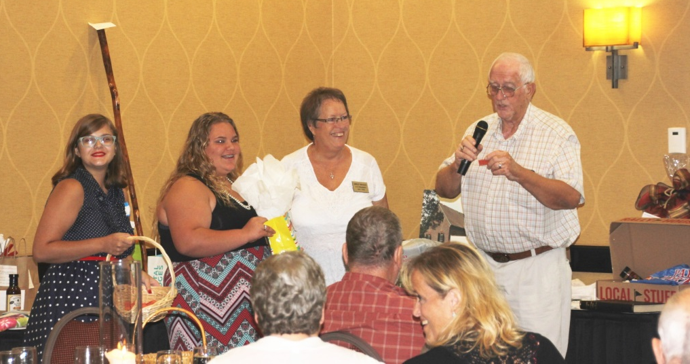
The Memorial service and Saturday night banquet is always the highlight of the reunion. Thanks to everyone who participated.

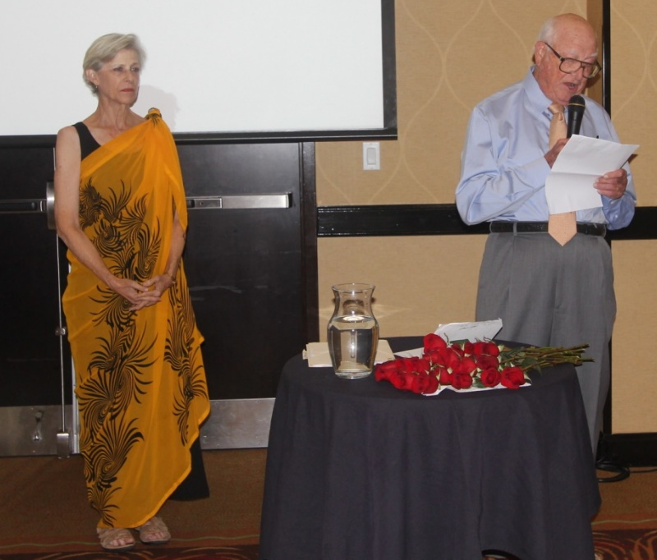

Page 4

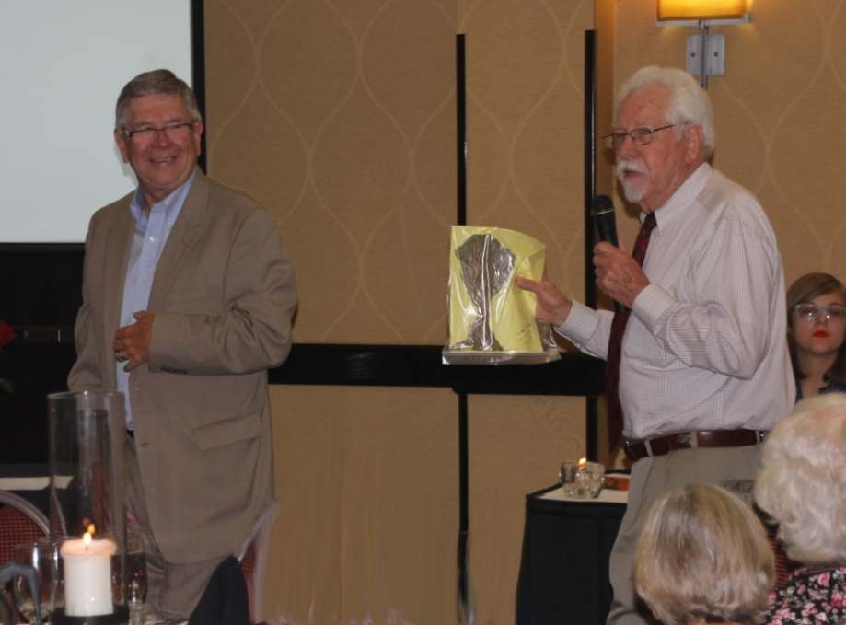

The auction of donated items was lots of fun and the proceeds go to support the Vauter’s Church in Virginia as well as the organization. A casual and fun get together was held on Thursday with plenty of food and conversation.

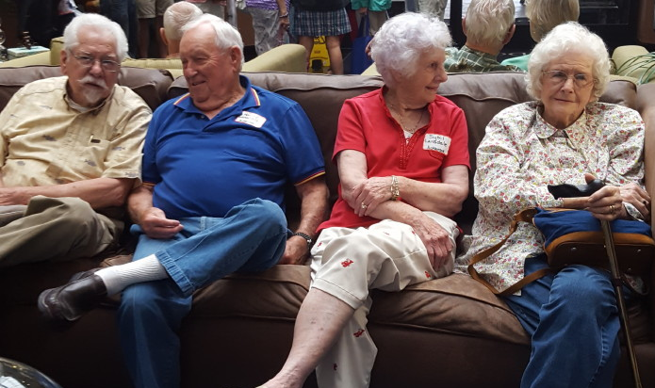

When family gets together there is not enough time to get caught up on information. Plan on attending the reunion next year in July in the great state of Texas. More details to come.

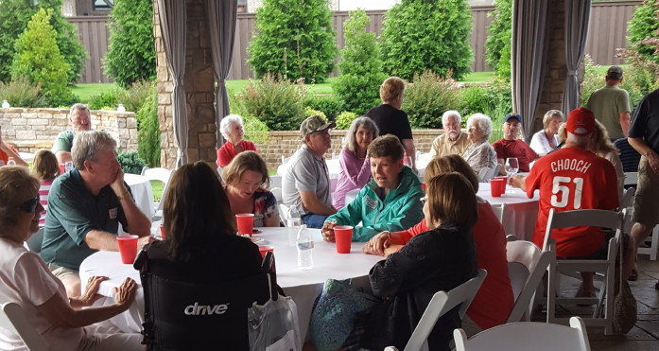 Page 5

Picturing Little Orphant Annie

By THE STAFF OF THE INDIANA MAGAZINE OF HISTORY

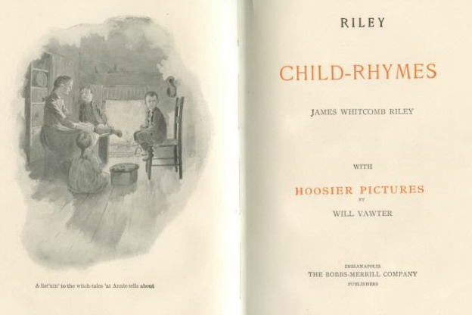
Posted August 26, 2013

Editorial illustrator Will Vawter became well known through his association with Hoosier poet James Whitcomb Riley, author of Little Orphant Annie.

John William Vawter, born in 1871 in West Virginia, will forever be associated with southern Indiana, for his work as both an illustrator and a painter.
After some study in New York and at the Herron Art School in Indianapolis, Vawter began his career as an illustrator for the Indianapolis Sentinel in 1891 and soon worked for other newspapers and magazines. It was his introduction in 1893 to poet James Whitcomb Riley, however, that would put Vawter’s art in the public eye. Over a thirty-year period, Vawter illustrated eleven volumes of Riley’s poems.
Two volumes with some of Riley’s most enduring poems offer excellent examples of Vawter’s work. The 1883 Riley Farm-Rhymes is accompanied by “Country Pictures by
Page 6

Will Vawter”; the 1890 volume of Riley Child-Rhymes is illustrated with the artist’s “Hoosier Pictures.” In both cases, Vawter’s miniature sketches and full-page illustrations appear throughout the book.
Farm-Rhymes begins with four pages of small sketches, including a scarecrow with five crows perching atop him, and a charming little rabbit watching a man and boy walk through a farm field.
Vawter adds emphasis to the rather gruesome stories told by Riley’s famous “Little Orphant Annie” with a full page illustration of the bewildered parents of the boy who “wouldn’t say his prayers” as they view his empty bed, and an even more pointed sketch of a little girl being “snatched . . . through the ceilin’” by two goblins.
In 1908, Vawter moved to Brown County, where he lived and worked for the rest of his life. He took up oil painting and became one of the respected and sought-after members of the Brown County School of artists. He also continued to work with Riley, and many of his later illustrations are based upon people he knew and observed in Brown County. Vawter died in 1941.
His work continues to be known as books of Riley poems are re-issued in their original editions, and his oil paintings command high prices at auctions of Hoosier artists.
Sources: Josephine Graf, “The Brown County Art Colony,” IMH, December 1939; www.willvawter.com and www.hancockcountyarts.com; James Whitcomb Riley, Riley Child-Rhymes and Riley Farm-Rhymes

Ghost Towns in Morrison County, Minnesota
Lemuria, Atlantis, The Great Zimbabwe, Kathmandu, Machu Picchu; all are lost cities, some of them now found. There is an attractive fog of mystery surrounding these cities and the ghost towns of the American West. I was interested to see how the definition of “lost city” compared with that of “ghost town”. According to the dictionary, a ghost town once thrived, but then was abandoned, or mostly abandoned, once a natural resource was used up. There was no dictionary definition for “lost city,” so I’ve come up with my own. A lost city is one that has been inaccessible to people for quite some time — so much time, in fact, that its history is unknown. Lost cities seem to have older civilizations than ghost towns.
In Morrison County, there are a number of abandoned towns that do not fall under the designation of either “lost city” or “ghost town”. In some of my research, these have been called “decadent towns”. The term has a strange ring to it, as though these towns disappeared through the raucous behavior of their residents. This is hardly the case.
Two towns that have disappeared from the Morrison County landscape are Dixville and Vawter. Dixville was located in Buckman Township about “8 miles east and two miles north of Royalton”. A post office was established there in 1895 with Gottlieb Schulz serving as the first postmaster. Prior to this, in the 1880s, a number of German immigrants moved to the area. Gottlieb was a peddler who served these immigrants by trading merchandise for their farm products.
Page 7

He decided to settle in the area and when the post office was established, he was required to come up with a name for it. He chose the name Dixville, after his horse named Dick.
The town had a school, a church (St. John’s Lutheran), a creamery and several stores. When postal service was discontinued in 1907, the town dwindled away. Union Cemetery, which was started in the 1880s in Dixville, is being cared for by the township and has been indexed by Marjean Keehr for the Historical Society.
The town of Vawter was founded in 1908 in northern Bellevue Township. The Minneapolis and Saulte Ste. Marie Railroad (Soo Line) had the town platted as it put in lines from Duluth to western Minnesota. The Soo Line apparently ran through John Schmolke’s property and he supposedly gave the town its name by commenting that there was “vater” everywhere. The truth of this legend is unknown, but the town grew to include a grain elevator, several stores, the Vawter Community Church, and a school. A postal drop was established in the community in 1922. Farmers near the town used Vawter to ship their goods via the railroad to markets in Duluth. By the 1940s, this shipping service and the post office were discontinued and the town disappeared.
Vawter still shows up on current plat maps, so my husband and I took a drive to go find signs of the village. When we got to the spot, all we saw were a number of private homes, one of which had some suspicious- looking, grass-covered humps of dirt. There is no visible evidence of Vawter left. Will Dixville and Vawter eventually become like the legendary Atlantis? Only time will tell.
by Mary Warner
Copyright 2001, Morrison County Historical Society

Vaughter Bridge, Tazwell Co., IL South of Hwy 9 on Benson Rd, crosses a stream. Does anyone know where this is located?

The following story was posted on the internet from a Vawter site, no name was attached to the document. I feel it offers some sense as we know the family came from the Normandy area and that the Valletorte family fought in the War of 1066. Surely they were skilled survivors.

Vawter family name means "guards"
"vakter" = "guards"
"vakt" = "guard", with the "er" = "s"

Page 8

Over the years there has always been interest to find out the early meaning of the family name "Vawter". In the early 1900s, the Bicknell book stated the Vawter name probably came from the French name Valletorte. Actually it came from Normandy.

It is true the Vawter family did come from the original Valletortes in Normandy, France before moving to England, but it's important to understand that Normandy was not a part of France proper. The region called "Normandy" in France was settled by Northmen, also called Normans.
The term Norman comes from the word "Northmen". They were basically Vikings who traded and settled along these coastal areas of France.
In a short time, these Vikings embraced Christianity and basic Judaism, and they were known as Normans.
Although the records show the Normans did have to learn to speak French, it is highly probable they kept their Viking family names. Very few people change their names, even when arriving in a new region. We see proof of this today when new immigrants arrive in America. Although they do their best to learn to speak English, they always keep their own family name.
Today, words from the original Viking-Norman language can be hard to find, but we still do see them used within the Swedish language.
In Sweden, the word for "guard is "vakt". To make this word plural is to add "er" to it, resulting in the word "vakter".
Not only do 5 of the 6 letters, and their pronunciations, fit perfectly with the word "vawter". but the hard "k" sound in the middle would easily be pronounced in Norman times as a "ll" moulle sound.
When Vikings settled coastal regions like Normandy they turned them into fortified trading posts, so it is likely some of these Vikings were guards, and they were known as "vakter".
It is highly likely the Vawter family during Norman times were guards. Just as in England we see a family named "Baker" was called this because their trade was as bakers, and a family named "Carpenter" had the "carpenter" skill. Similarly, the Vawter family were likely "vakters" (guards) because that is what their job was. Today it is still common in Sweden for people to be known by what they do, by what their skill is.
The fact that the Vikings (Normans) soon embraced Christianity and basic Judaism in Normandy, shows that the beauty and love of these teachings offer much more than the pagan religious ideas that the Vikings had originally brought with them.

I do not know the family connection of this person, but posting for future research
Mary LARIMORE was born on 12 Feb 1795. She was also known as Polly.
Parents: James LARIMORE and Caty MORGAN.
Spouse: Joseph Earl VAWTER.

Page 9

Vawter Family Reunion in Indiana 1947
The Vawter family of Tipton County Indiana had reunions the first weekend of August each year for many years. This photo taken in 1947 when Georgene Jurgensen’s father, George Dunn, attended with his family from Iowa. Ada Vawter is George’s Grandmother.

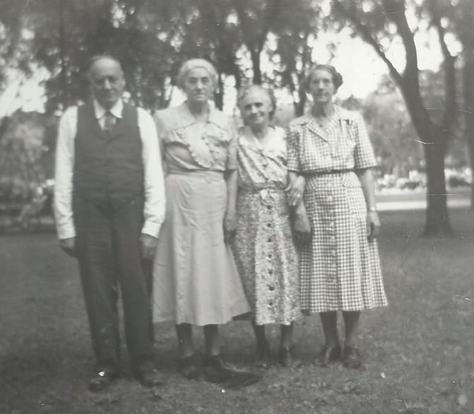

Left to right are 1 brother and three sisters of the line of George W. Vawter of Tipton, Indiana. They are William Vawter 1871 – 1949. Bill went to Michigan at a young age and Bill’s son Robert was active in the VVV family association for many years. Next is Ada Ann Vawter 1876 -1951. Ada was almost 6 foot tall. Next is Cora Ellen “Cory” Vawter/Kessler 1881 - 1962. She was adopted as an infant by her Aunt Rosalie Vawter Kessler. Last is Ida Belle Vawter 1878 – 1962, who lived in Tipton, IN and died in a tragic fire in her home.

George W. Vawter died in 1887 of typhoid fever after the loss of his wife Mary Simpson in 1885 in child birth. He had remarried in 1886 but the step mother was unable to care for the youngest child Cora and she was taken in by her Aunt Rosalie. The children all at young ages were separated and taken in by family. Ada worked as a servant and child care provider in the area. William left and went to Michigan. It seems they maintained a strong bond and the reunions had to have been very important to keep their family connection. Ada is my direct line as she married John Dunn, who had a son George Dewey Dunn, who had a son George Eugene Dunn who had me Georgene Dunn Jurgensen.

Just like the many reunions of today, a way to connect to the past, and look to the future.

Page 10
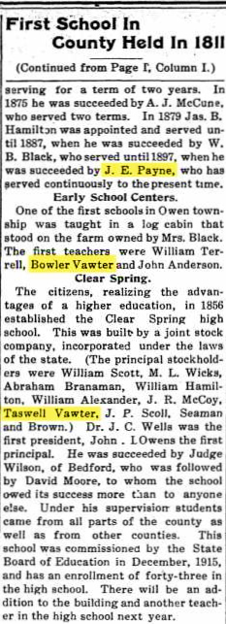
Brownstown (Jackson County), Jackson County, Indiana, US
Brownstown Banner article "First School in County Held in 1811" which is a summary of the history of schools in Jackson County, IN. Bowler Vawter is listed as one of the first teachers. In 1856 the first Clear Spring high school was established built by a joint stock company of which Tazwell Vawter was a principal.

Will of Ann Vawter 1790

When researching in Virginia in 2015, I found the will of Ann Vawter. The index had a weird spelling but the original will is clear on the spelling of Vawter.
Georgene Jurgensen

In the name of God 11th day of April 1790
I Ann Vawter of Essex State of Virginia. Land where I live to son Bowler Vawter upon his death to grandson, Redmund Berry Vawter. If he dies without heirs to the next son of Bowler Vawter. Give to daughter Rhoda Vawter one red trunk. All the rest ot Bowler Vawter. Witnesses: Obeidiah Boulward, John Coghill, Nancy Coghill and Delphia Boulware. Signed Ann Vawter (her mark)
21 day August 1794 will was proved in Essex County, but not recorded until 16 April 1810.
(the will book changed from the 1700’s to the 1800’s so that was why it was not found in the 1790’s)

Page 11

Vawter Vauter Vaughter Family Association - The 40th Annual Reunion
Bentonville, Arkansas
Business Meeting. The meeting was called to order at the Doubletree Hilton Inn, Bentonville, Arkansas by President Darren Welch. Ringing of the cowbell was by Corrine Smith. The Pledge of Allegiance was led by Reba Alexander. The opening prayer was given by Judge Fred Wicker. There were 61 people present for the meeting.
Ellen Cummings gave the Site Committee report. The 2017 reunion will be in San Antonio, Texas. Indiana will be the site of the 2018 reunion, Kansas for 2019, and then to Virginia for 2020.
The Registration report was given by Jordan Johnston. Currently 81 people are registered or participating in the reunion.

Memorial Service was presented by Ellen Wicker Cummings. Fred Wicker read scripture from Rev. Fall which was originally read at the VVV first reunion memorial service. Michelle Alexander signed song “Blessings”.
Those remembered: Lemma W. Swafford, Jerry Waters, Nicholas Schapmire, Alice Louis Vawter Slater, Robert Allen Wiley, Pearl Elisabeth Robbins Wiley, Norma Stein “Bannie” Vaughters, Evelyn T. Vawter, Billy Arthur Vawter, George Roy Vawter Jr., Freddy G. Vawter, Lewis O Vawter Jr, Martha J “Marty” Jones, Mary Terry Noble Vawter, Paul W. Bowman, David Owen Cottle, Harold E Vawter, James Lanier Vawter, Richard Mark Hudson, Norma Jean Vawter, Dorothy Vawter, Ruth L. Vawter, Virgil R. Weidner, Bruce Vawter

Military veterans were asked to stand and be recognized. Navy: Margie Hudson, Charles Wilhelm, Jordan M. Johnston, Keith Vaughters, Harold Dee Lansdale. Army: Jerry Beasley, B. Ray Mize. Air Force: Robert L Vawter, Ken Wicker, Fred Wicker, Morris Slater. Marines: Tom Hood.
Youngest attending: Corrine Smith, 2
Oldest attending: Harold Dee Lansdale, 92 (with Honorable mention to Fred Wicker, 3 days younger).
Married longest: Norma & Ken Wicker, Morris & Ellen Slater, 61 years
Roll-call of states: The winning state was Mississippi with 14, closely followed by Kansas with 12. The rest: Texas 9; Illinois 9; Arkansas 7; Missouri 7; Louisiana 6; Delaware, Kentucky, Tennessee, and Virginia all with 3; Indiana 2; and Arizona, California, Colorado, and Oklahoma all with 1.
Corrected Final registration: 86
Vauter Church Love Offering of $1187 plus Auction Proceeds of $945 equaled $2132 to be sent to Vauter’s Church.

Page 12

